AI ASSITANT CODING
ASSIGNMENT-16
M.SHIVAMANI
2303A52344
BATCH-38

Title: Database Design, Query Optimization, and Analysis using AI Tools

Task 1 – Hospital Management Database Prompt Used
Create schema and queries for a Hospital Management System with tables Doctors, Patients, and Appointments including constraints and analytical queries.

Code

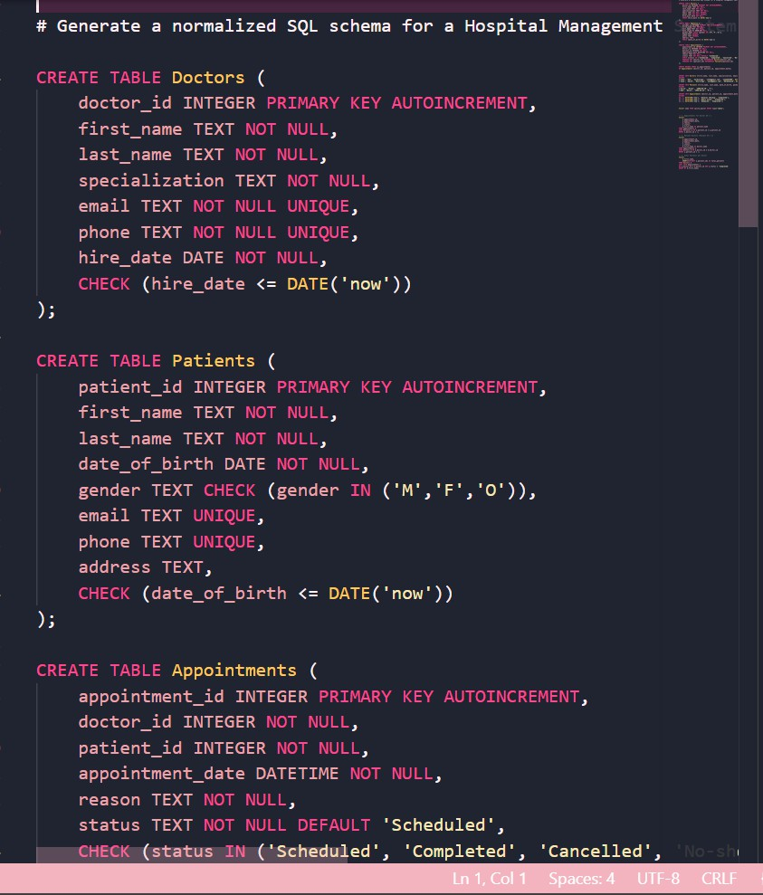

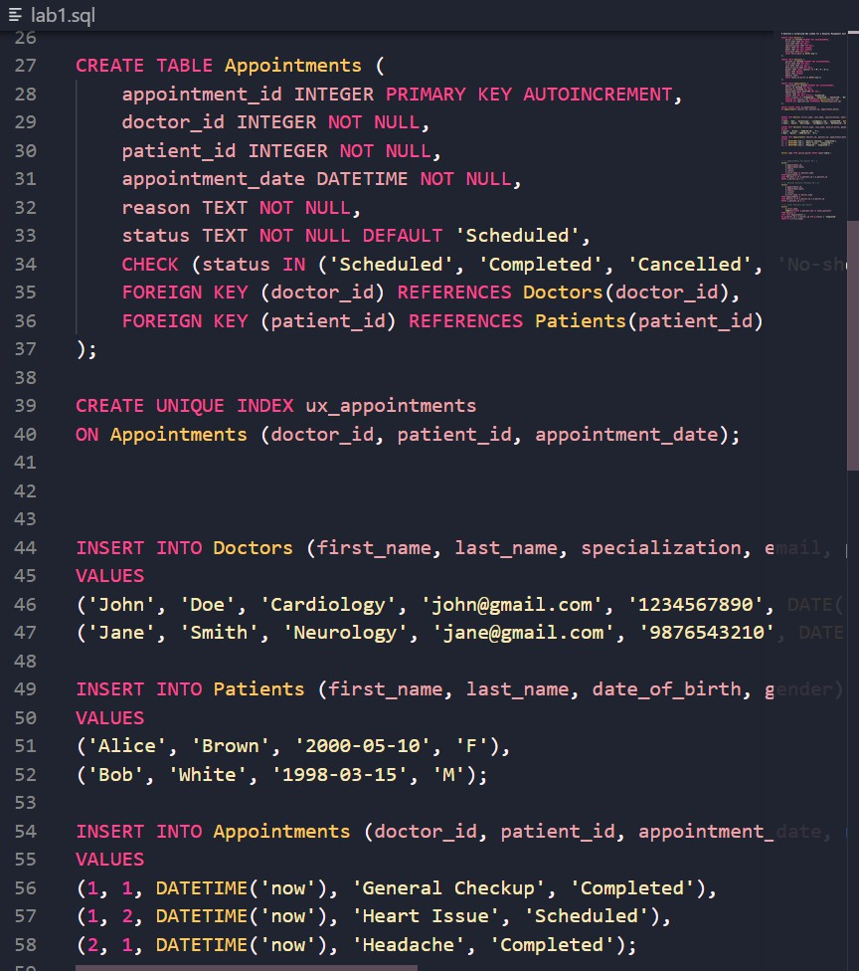

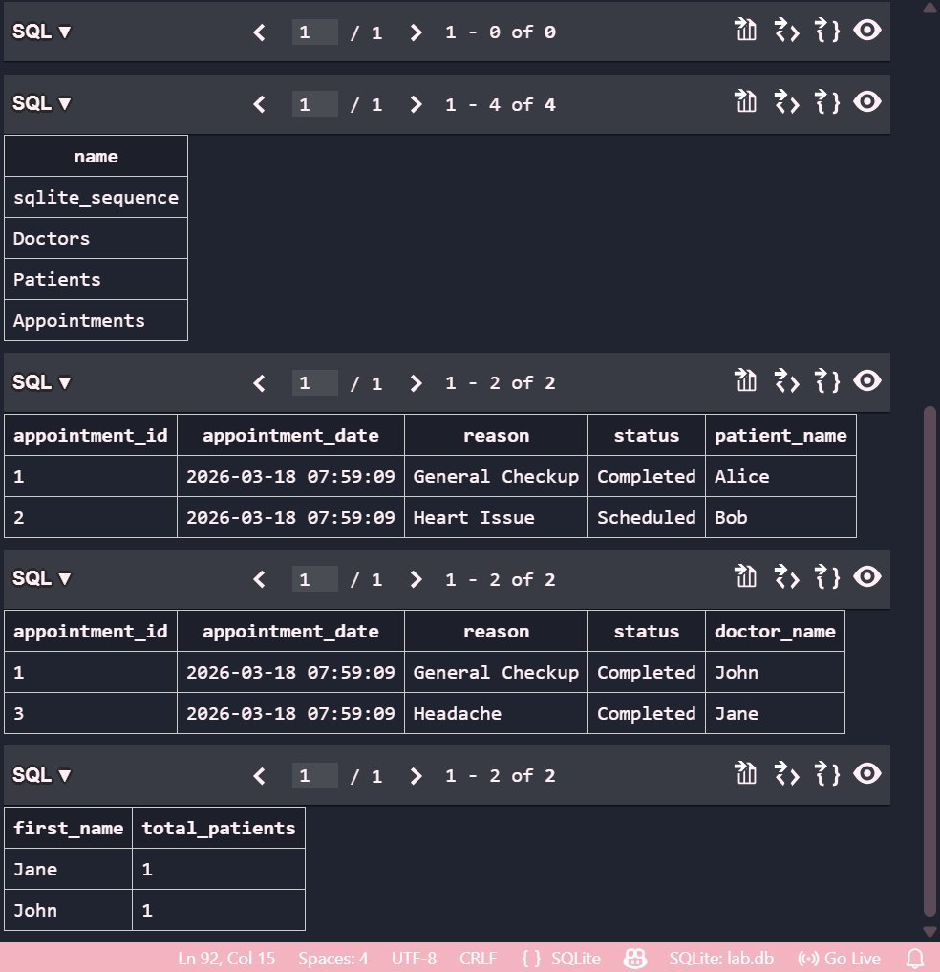
Explanation
This task focuses on designing a Hospital Management System database.
- The Doctors table stores doctor details.
- The Patients table maintains patient records.
- The Appointments table links doctors and patients. Foreign keys ensure relationships:
- A doctor can have multiple appointments.
- A patient can book multiple appointments. Queries were created to:

- List all appointments for a specific doctor
- Retrieve patient history
- Count total patients treated by each doctor
This schema follows normalization principles and ensures efficient data handling.

Task 2 – Online Shopping Database Prompt Used
Design an e-commerce database with Users, Products, Orders, and OrderDetails tables, including analytical queries and optimization suggestions.

Code

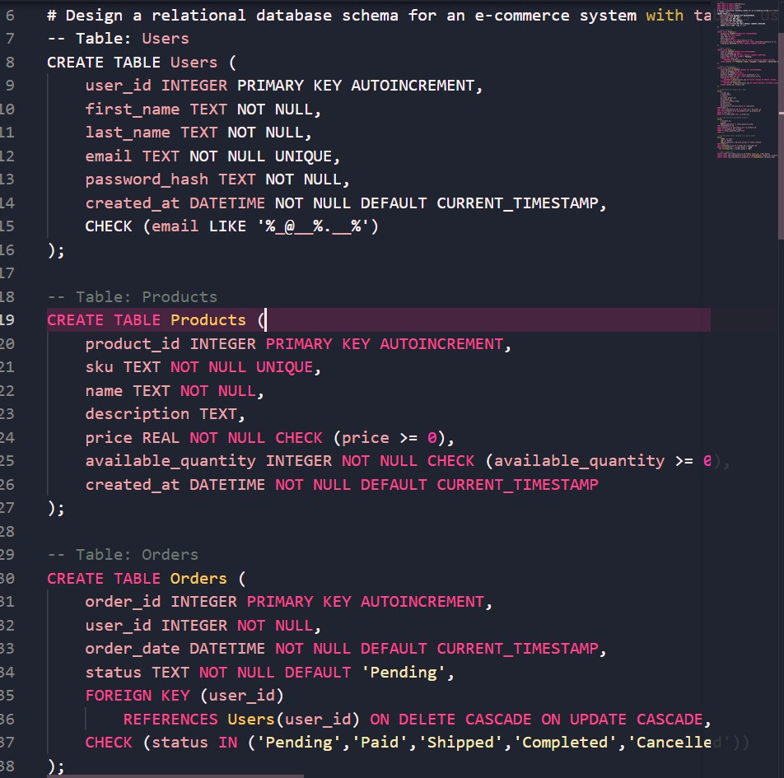

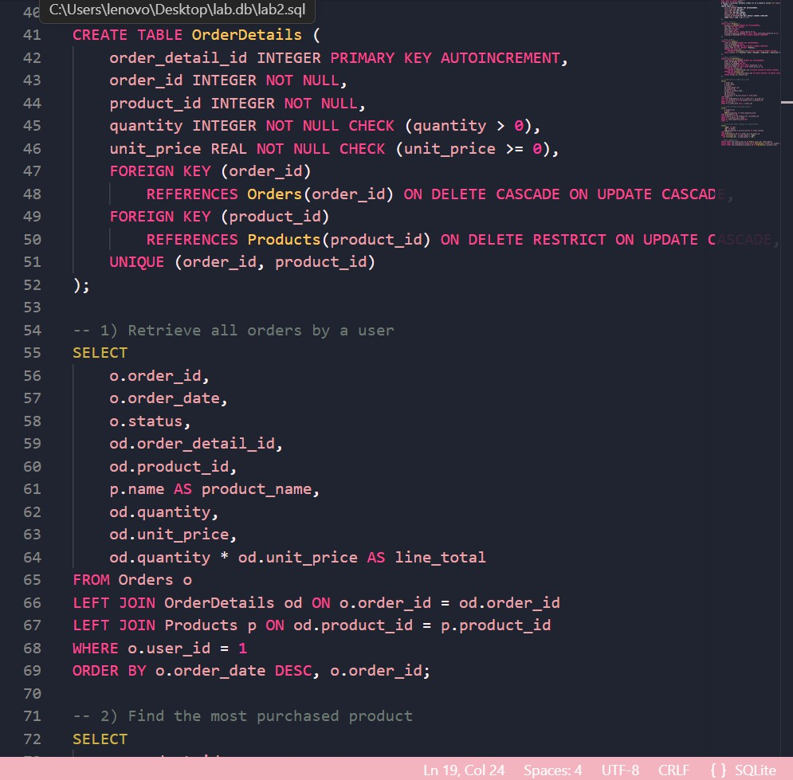

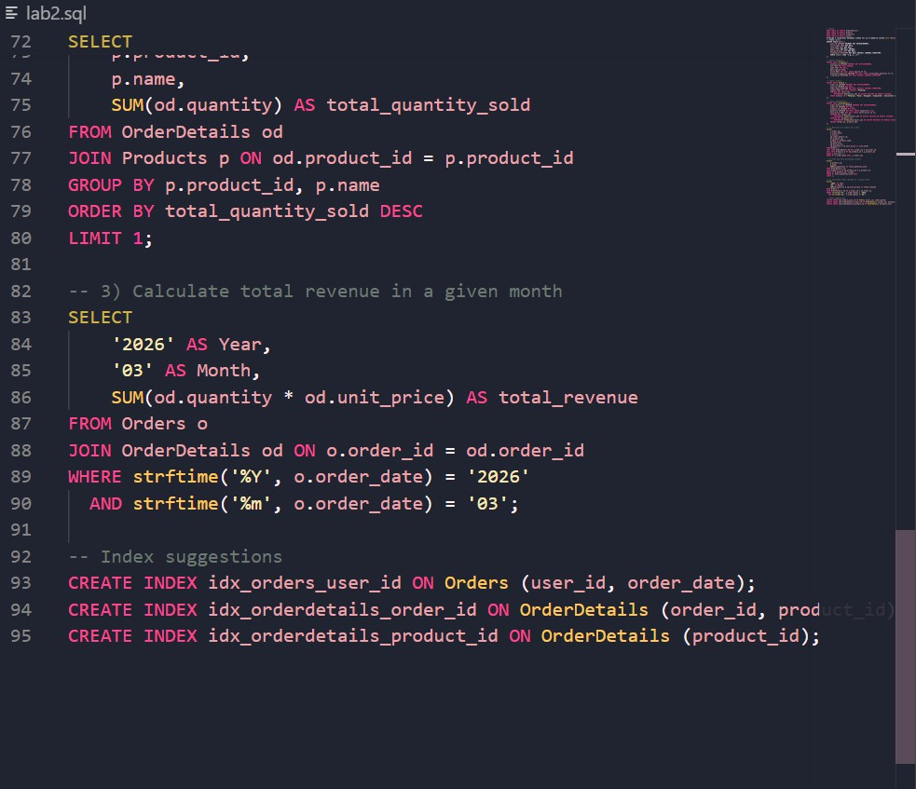

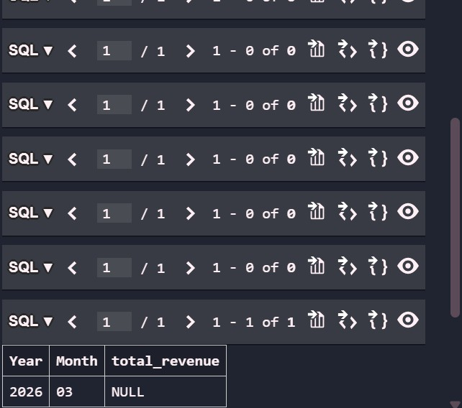
Explanation
This task implements a real-world online shopping system.
- Users table stores customer data.
- Products table contains product information.
- Orders table tracks purchases.
- OrderDetails stores items per order. Queries include:
- Retrieving all orders by a user
- Finding the most purchased product
- Calculating monthly revenue AI suggested improvements:

- Splitting categories into separate tables
- Using indexes for faster queries
- Avoiding redundancy through normalization

Task 3 – Library Management System Prompt Used
Design a library system with Books, Members, and Loans tables including indexing strategies and queries.

Code

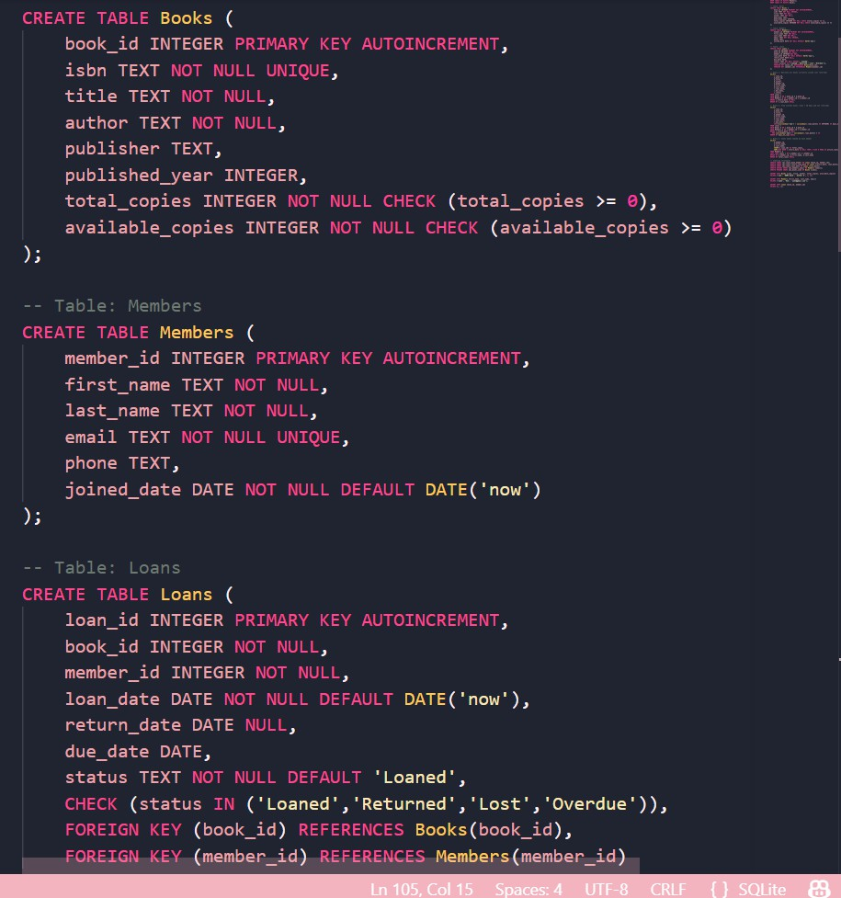

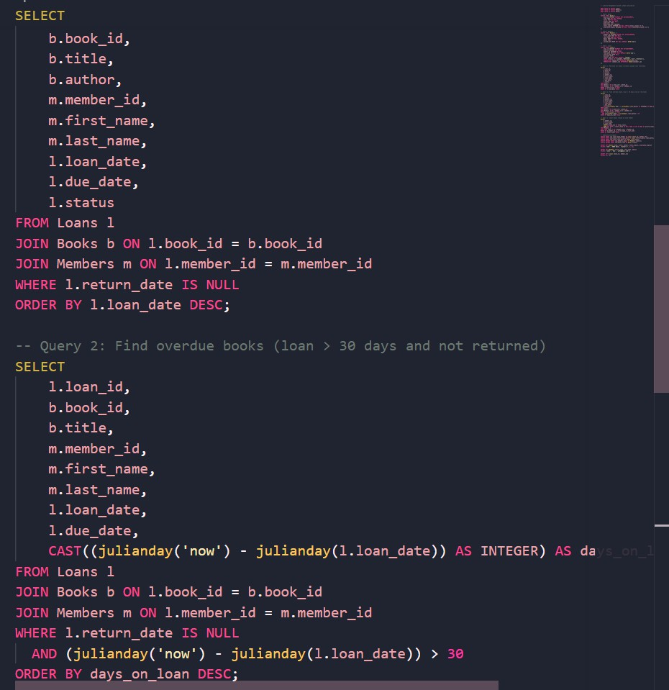

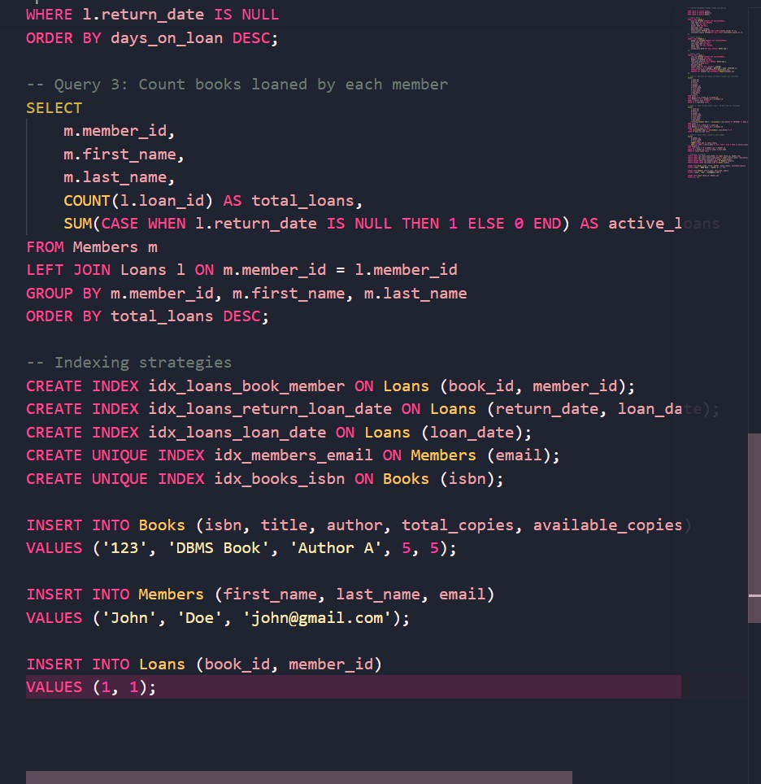

Explanation
This task models a Library Management System.
- Books table tracks book inventory
- Members table stores user details
- Loans table manages borrow/return activity Queries implemented:
- Retrieve issued books

- Find overdue books
- Count loans per member Indexing improves performance:
- Faster searches on loan_date
- Efficient joins using foreign keys
- Quick member lookup via email index

Task 4 – Query Optimization Prompt Used
Analyze and optimize inefficient SQL queries using joins instead of subqueries.

Code
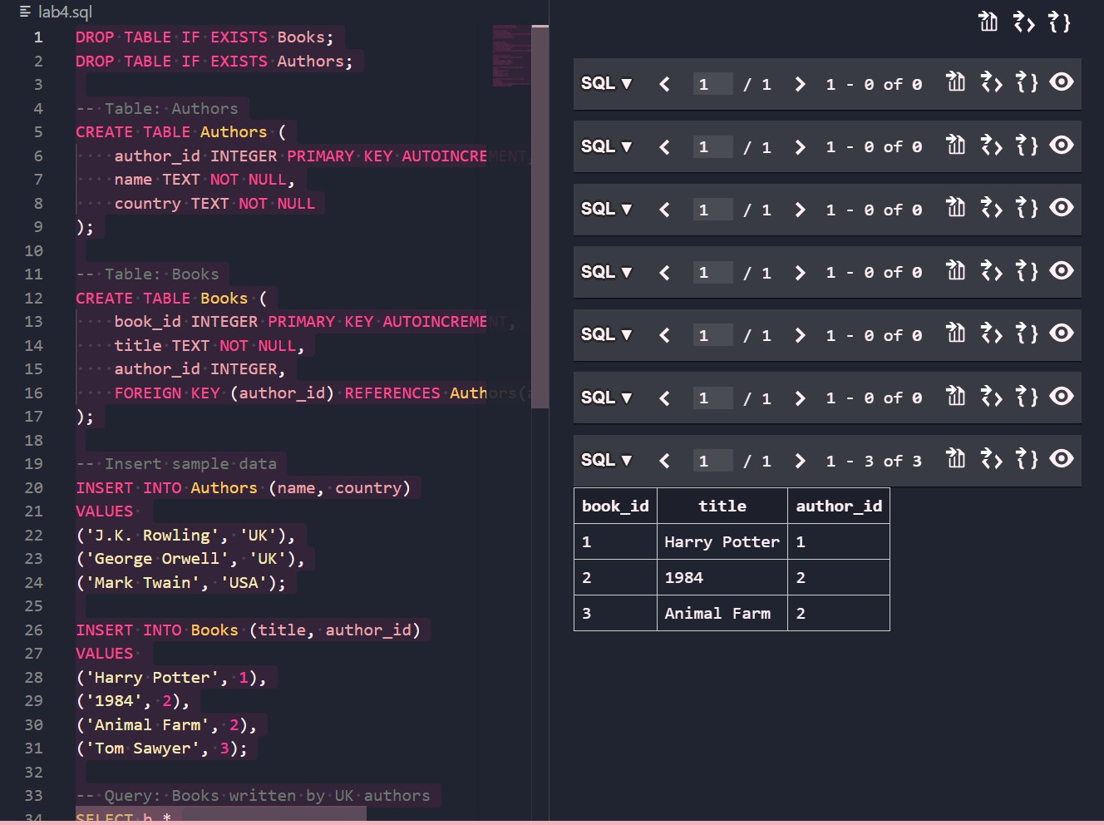

Explanation

This task demonstrates query optimization techniques.
- Original query uses a subquery
- Optimized query uses JOIN Key observations:
- JOIN improves performance
- Reduces execution time for large datasets
- Both queries produce identical results
This highlights the importance of writing efficient SQL queries.

Task 5 – University Course Registration System Prompt Used
Design a course registration system with Students, Courses, Faculty, and Registrations tables along with analytical queries.

Code

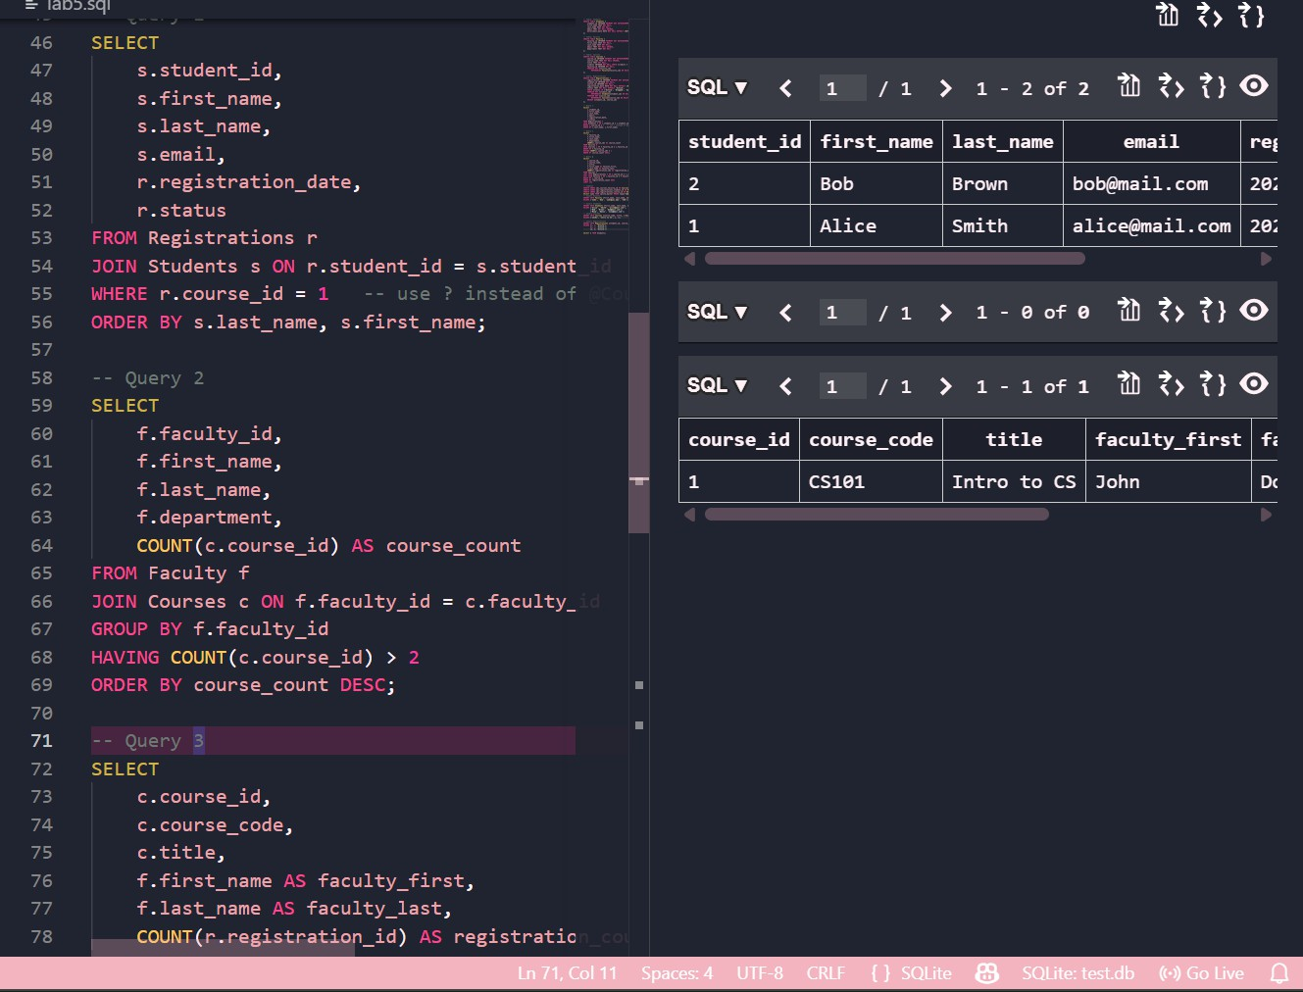

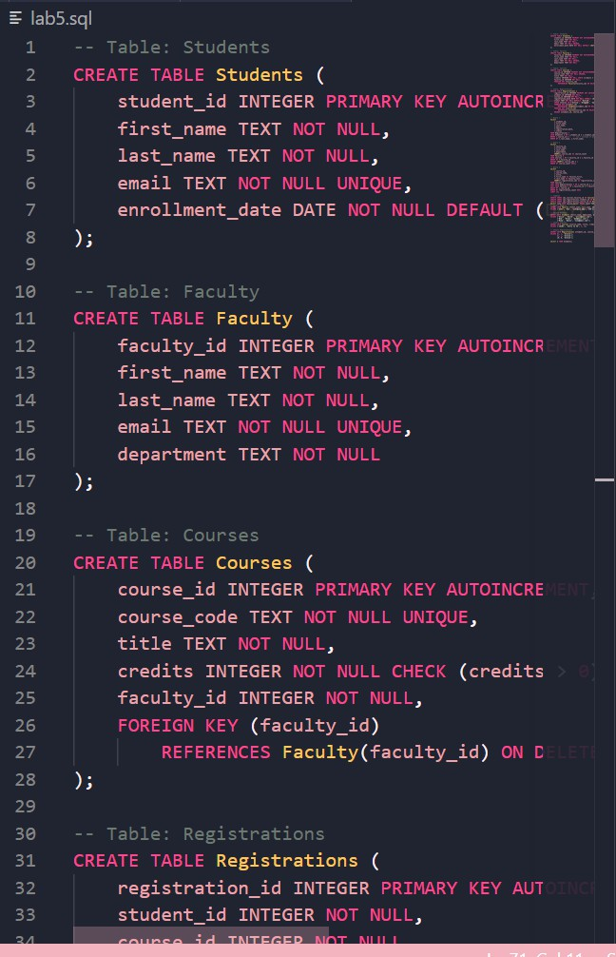

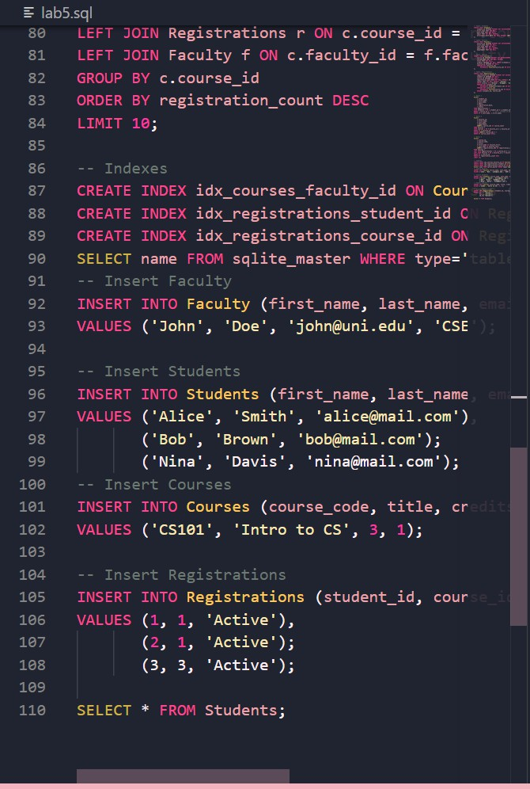

Explanation
This task builds a university course registration system.
- Students table stores student data
- Faculty table contains instructor details
- Courses table links faculty to courses
- Registrations table manages student enrollments Relationships:
- One student → many courses
- One faculty → many courses Queries include:
- Listing students in a course
- Finding faculty teaching more than 2 courses
- Identifying most popular courses
This design ensures scalability and efficient querying.

Final Conclusion: Role of AI in AIAC Lab
AI-assisted coding significantly enhanced the efficiency and learning experience throughout this assignment.
- AI helped generate structured database schemas quickly
- Reduced syntax errors and debugging time
- Provided optimization strategies for better performance
- Enabled understanding of real-world database design concepts
AI tools like Copilot act as intelligent assistants, guiding developers in writing clean and efficient code. However, understanding the underlying logic remains essential to effectively use these tools.
Overall, AIAC demonstrates how AI can accelerate development while also improving conceptual clarity in database management and query optimization.

